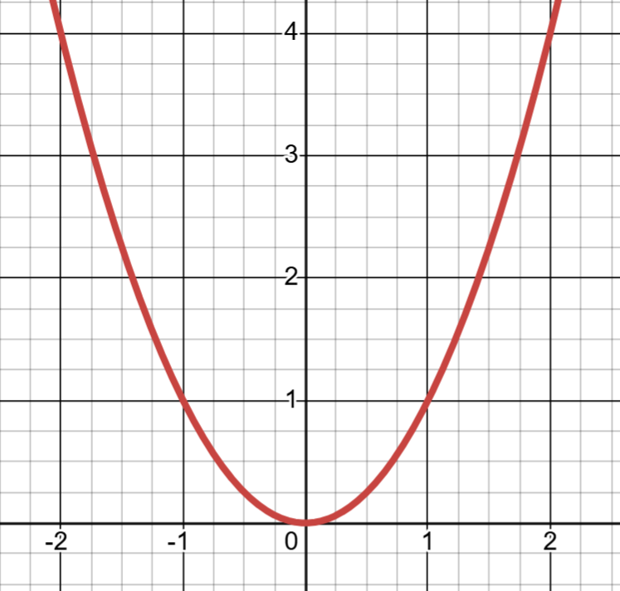
Use the graphs of $y=x^{2}$ to estimate the solutions to the following equations
$$x^{2}=1$$ | $$x^{2}=3$$ | $$x^{2}-2=0$$ | $$x^{2}-0.5=0$$ | $$x^{2}=x+1$$
$$x^{2}-x-2=0$$ |  | $$x^{2}-2x=2$$ |  | $${2x}^{2}-2x-2=-1$$

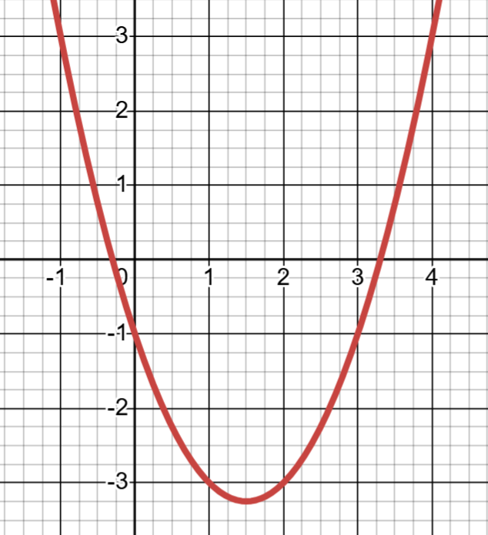
Use the graphs of $y=x^{2}-3x-1$ to estimate the solutions to the following equations
$$x^{2}-3x-1 =1$$ | $$x^{2}-3x-1 =-2$$ | $x^{2}-3x-2=0$ | $$x^{2}-3x-2=1$$
$$x^{2}-3x-3=1$$ |  | $$x^{2}=3x-1$$ | $$x^{2}-3x-1=0.25x$$

