L  M |  | N
 |  | J
H
G
C
b
P
Q
RR
SR
O
F
K
D
E
a

Write following vectors in terms of a and b

- $\overset{→}{CD}$
- $\overset{→}{CE}$
- $\overset{→}{CG}$
- $\overset{→}{CP}$
- $\overset{→}{CN}$
- $\overset{→}{DS}$
- $\overset{→}{EO}$
- $\overset{→}{DR}$
- $\overset{→}{GR}$
- $\overset{→}{HO}$
- $\overset{→}{MQ}$

Write following vectors in terms of a and b

- $\overset{→}{DC}$
- $\overset{→}{EC}$
- $\overset{→}{GC}$
- $\overset{→}{PC}$
- $\overset{→}{NC}$
- $\overset{→}{SD}$
- $\overset{→}{OE}$
- $\overset{→}{RD}$
- $\overset{→}{RG}$
- $\overset{→}{HO}$
- $\overset{→}{QM}$

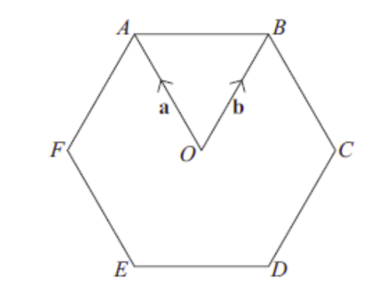
Write the following vectors in terms of a and b
- $\overset{→}{OB}$
- $\overset{→}{BO}$
- $\overset{→}{AO}$
- $\overset{→}{DA}$
- $\overset{→}{EB}$
- $\overset{→}{FB}$
- $\overset{→}{FC}$
- $\overset{→}{AB}$
- $\overset{→}{ED}$

Write three different ways of getting from E to C

