Attempt the following UKMT question
An example of how to solve a similar question and some follow up questions are on the next page
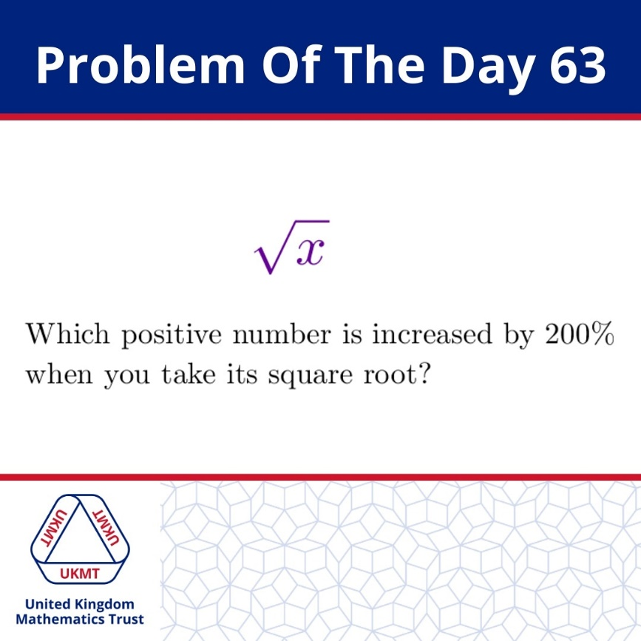

Example  What positive number ($x>0)$  is increased by 100% when you take its square root?  $$+100\% ≡ ×2$$  $$So let x be the positive number$$  $$2x=\sqrt{x}$$  $$4x^{2}=x$$  $$4x=1$$  $$x=\frac{1}{4}$$ | Follow up Question 1:  What positive number ($x>0)$  is increased by 300% when you take its square root? | Follow up Question 2:  What positive number ($x>0)$  is increased by 500% when you take its square root?
Follow up Question 3:  What positive number ($x>0)$  is increased by 50% when you take its square root?  $$+50\% ≡ ×\frac{3}{2}$$ | Follow up Question 4:  What positive number ($x>0)$  is increased by 10% when you take its square root? | Follow up Question 5 (Generalised)  What positive number ($x>0)$  is increased by $100n\%$when you take its square root and $n$ is a positive integer?

