Cubic Graphs
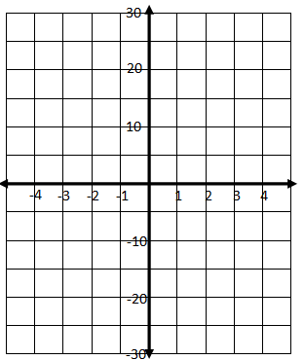
I DO EXAMPLE:
- Complete the following table for the equation
y = x³, for -3 $≤x ≤$ 3:

x | -3 | -2 | -1 | 0 | 1 | 2 | 3
y

b) Draw the graph of y = x³ on the grid:

WE DO Example:
Complete the following table for the equation
y = x³ + 1, for -3 $≤x ≤$ 3:

x | -3 | -2 | -1 | 0 | 1 | 2 | 3
y

b) Draw the graph of y = x³ + 1 on the grid:

YOU DO QUESTIONS :

1a) Complete the following table for the equation
y = x³ + 2 for -3 $≤x ≤$ 3:

x | -3 | -2 | -1 | 0 | 1 | 2 | 3
y

b) Draw the graph of y = x³ + 2 on the grid:

2a) Complete the following table for the equation
y = x³ - 1, for -3 $≤x ≤$ 3:

x | -3 | -2 | -1 | 0 | 1 | 2 | 3
y

b) Draw the graph of y = x³ - 1 on the grid:

YOU DO QUESTIONS :

3a) Complete the following table for the equation
y = x³ + 3 for -3 $≤x ≤$ 3:

x | -3 | -2 | -1 | 0 | 1 | 2 | 3
y

b) Draw the graph of y = x³ + 3 on the grid:

4a) Complete the following table for the equation
y = x³ - 2, for -3 $≤x ≤$ 3:

x | -3 | -2 | -1 | 0 | 1 | 2 | 3
y

b) Draw the graph of y = x³ - 2 on the grid:

